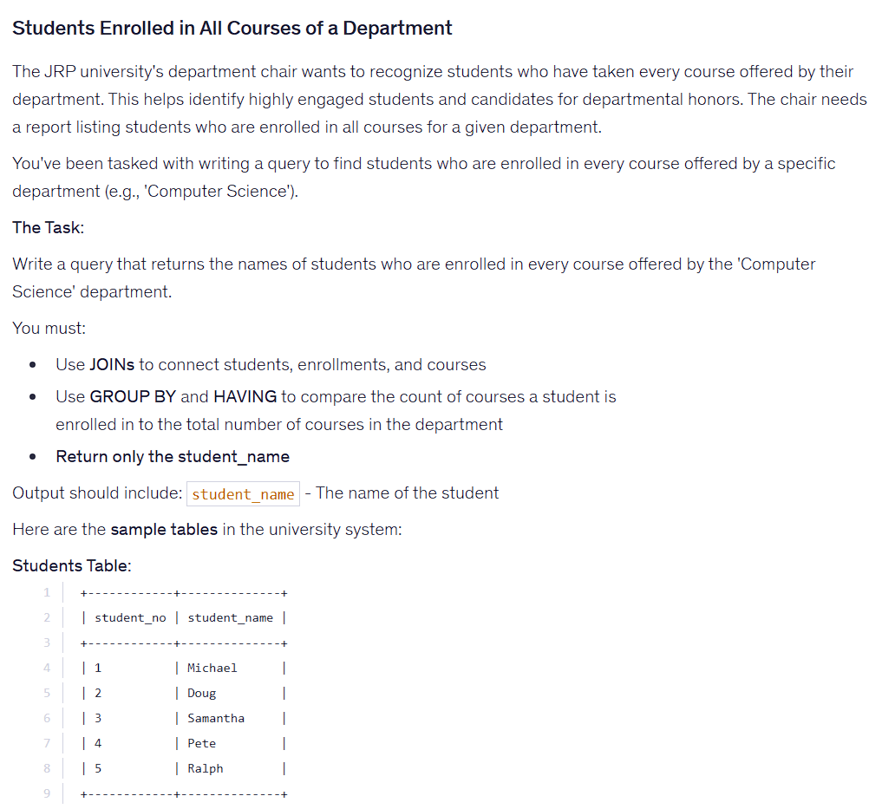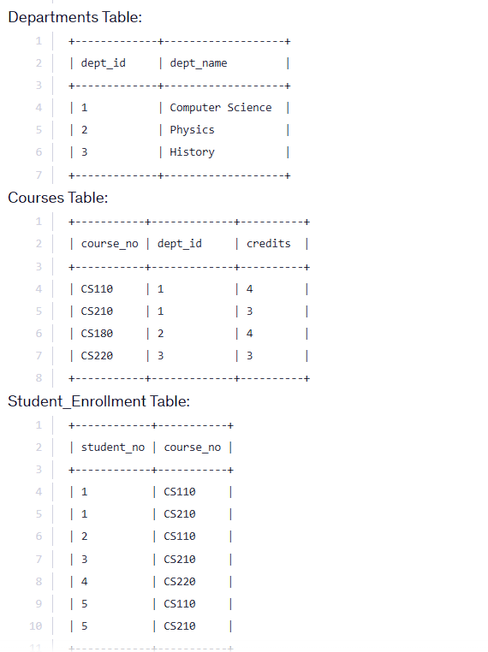
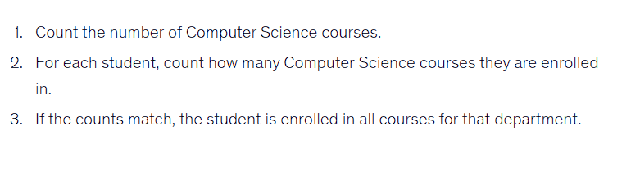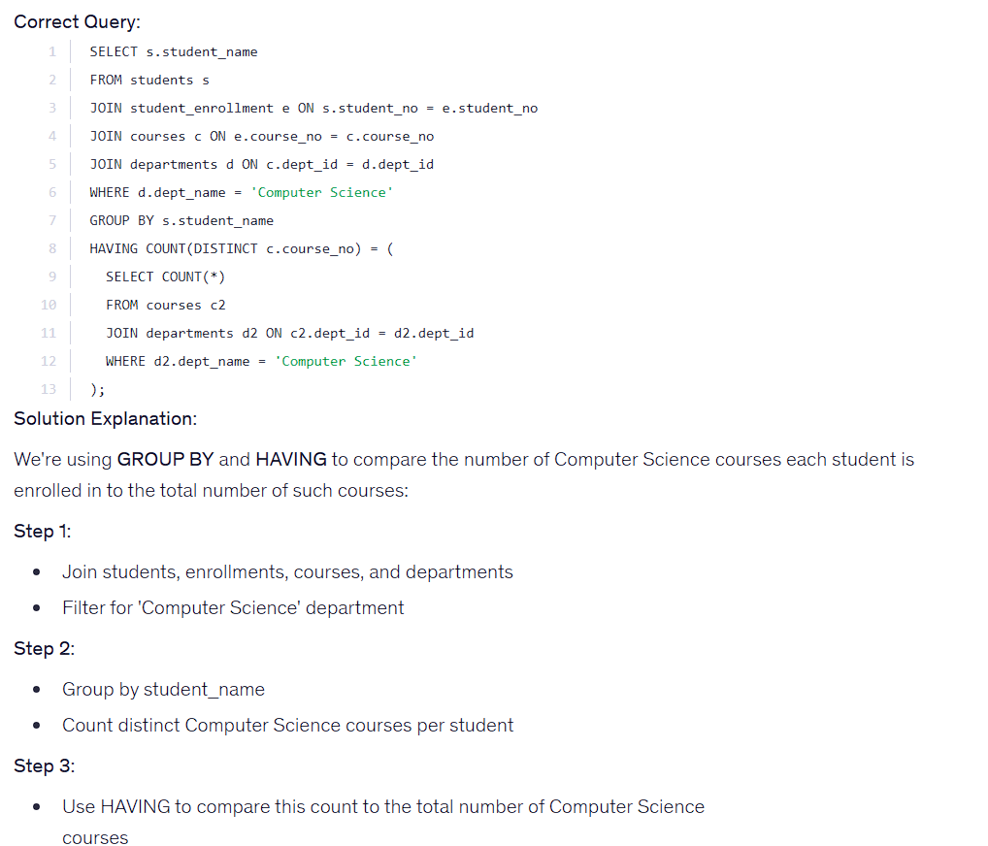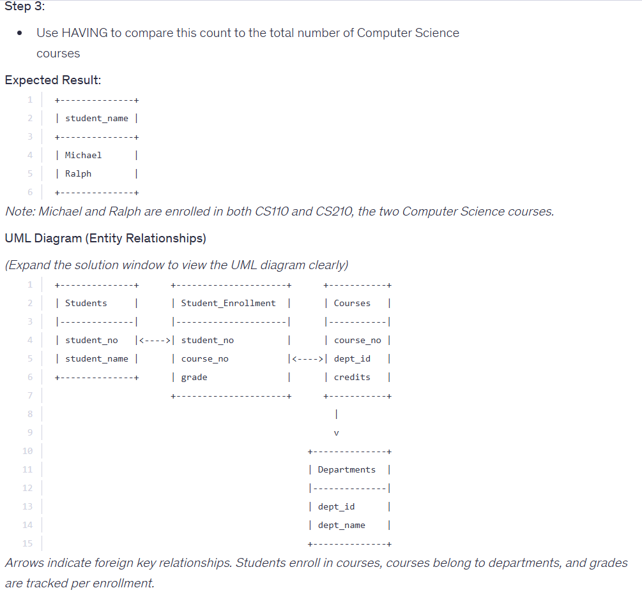

SELECT s.student_name
FROM students s
JOIN student_enrollment e ON s.student_no = e.student_no
JOIN courses c ON e.course_no = c.course_no
JOIN departments d ON c.dept_id = d.dept_id
WHERE d.dept_name = 'Computer Science'
GROUP BY s.student_name
HAVING COUNT(DISTINCT c.course_no) = (
SELECT COUNT(*)
FROM courses c2
JOIN departments d2 ON c2.dept_id = d2.dept_id
WHERE d2.dept_name = 'Computer Science'
);

